Banker’s Algorithm
Banker’s algorithm is a deadlock avoidance algorithm. It is named so because this algorithm is used in banking systems to determine whether a loan can be granted or not.
Consider there are n account holders in a bank and the sum of the money in all of their accounts is S. Everytime a loan has to be granted by the bank, it subtracts the loan amount from the total money the bank has. Then it checks if that difference is greater than S. It is done because, only then, the bank would have enough money even if all the n account holders draw all their money at once.
Banker’s algorithm works in a similar way in computers. Whenever a new process is created, it must exactly specify the maximum instances of each resource type that it needs.
Let us assume that there are n processes and m resource types. Some data structures are used to implement the banker’s algorithm. They are:
- Available:It is an array of length m. It represents the number of available resources of each type. If Available[j] = k, then there are k instances available, of resource type Rj.
- Max: It is an n x m matrix which represents the maximum number of instances of each resource that a process can request. If Max[i][j] = k, then the process Pi can request atmost k instances of resource type Rj.
- Allocation: It is an n x m matrix which represents the number of resources of each type currently allocated to each process. If Allocation[i][j] = k, then process Pi is currently allocated k instances of resource type Rj.
- Need: It is an n x m matrix which indicates the remaining resource needs of each process. If Need[i][j] = k, then process Pi may need k more instances of resource type Rj to complete its task.
Need[i][j] = Max[i][j] - Allocation [i][j]

Safety Algorithm:
- Let Work and Finish be vectors of length m and n, respectively. Initially,
Work = Available
Finish[i] =false for i = 0, 1, ... , n - 1.
This means, initially, no process has finished and the number of available resources is represented by the Available array.
- Find an index i such that both
Finish[i] ==false
Needi <= Work
If there is no such i present, then proceed to step 4.
It means, we need to find an unfinished process whose need can be satisfied by the available resources. If no such process exists, just go to step 4.
- Perform the following:
Work = Work + Allocation;
Finish[i] = true;
Go to step 2.
When an unfinished process is found, then the resources are allocated and the process is marked finished. And then, the loop is repeated to check the same for all other processes.
- If Finish[i] == true for all i, then the system is in a safe state.
That means if all processes are finished, then the system is in safe state.
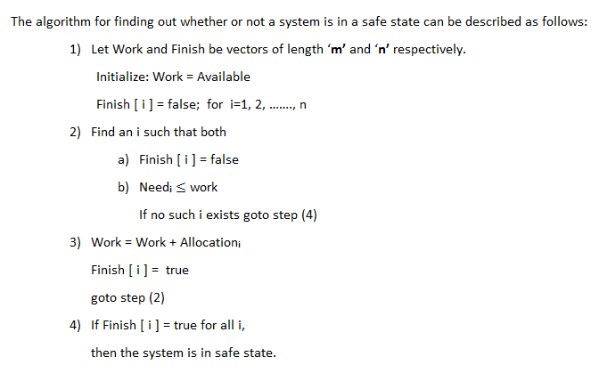

Resource Request Algorithm:
This describes the behavior of the system when a process makes a resource request in the form of a request matrix. The steps are:
- If number of requested instances of each resource is less than the need (which was declared previously by the process), go to step 2.
- If number of requested instances of each resource type is less than the available resources of each type, go to step 3. If not, the process has to wait because sufficient resources are not available yet.
- Now, assume that the resources have been allocated. Accordingly do,
Available = Available - Requesti
Allocationi = Allocationi + Requesti
Needi = Needi - Requesti
This step is done because the system needs to assume that resources have been allocated. So there will be less resources available after allocation. The number of allocated instances will increase. The need of the resources by the process will reduce. That’s what is represented by the above three operations.
After completing the above three steps, check if the system is in safe state by applying the safety algorithm. If it is in safe state, proceed to allocate the requested resources. Else, the process has to wait longer.
